Welcome to your new Cisco Hosted Collaboration System!
Important Things to Know:
- You will continue to dial 9 for external calls
- Your extension (and voicemail ID) is your 10-digit direct dial (DID) number
Your new dialing patterns:
- To call internal.
  - Dial xxxxxxxxxx (10-digit DID phone number)

- External calling (Local and Long Distance)
  - Dial 9 + telephone number
- International Calling (if allowed)
  - Dial 9 the country code + the number
What you need to do first:
- You need to set up your new voicemail box
  - Temporary pin is 1379
  - Record your name and a personal greeting.
  - You must change your pin. 4-10 digits. No 1111, 1234, or similar. Cannot be 1379.
  - Do not hang up before you hear “You have finished enrollment”
- Express messaging - Leave a message without ringing the other extension or transfer to voicemail.
  - Dial: *XXXXXXXXXX(*10-digit ext number)

Access Jabber Account:
- Log in using your AD credentials

Once jabber is loaded on your pc you will have the following icon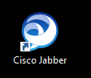

Double click on the icon and follow the steps below to access the Cisco Jabber Client

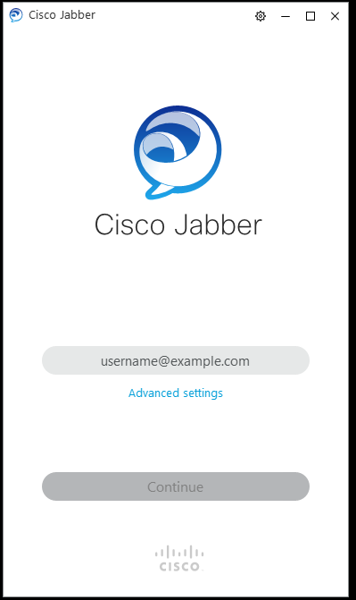
Enter your AD credentials
(EX: angie.rudisill@doveresg.com)
Click on continue.

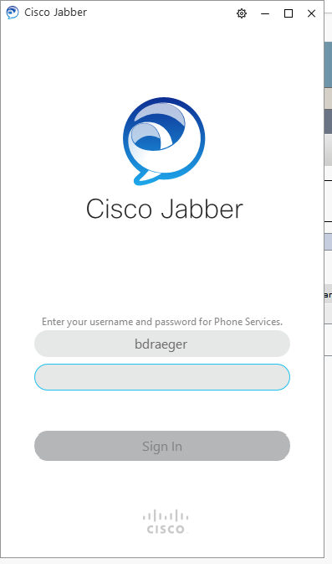
Click Sign In
Enter your AD password
The following screen will display and you will be ready to use the jabber client softphone.
You can follow thru the pop up guide to provide information about the jabber client.
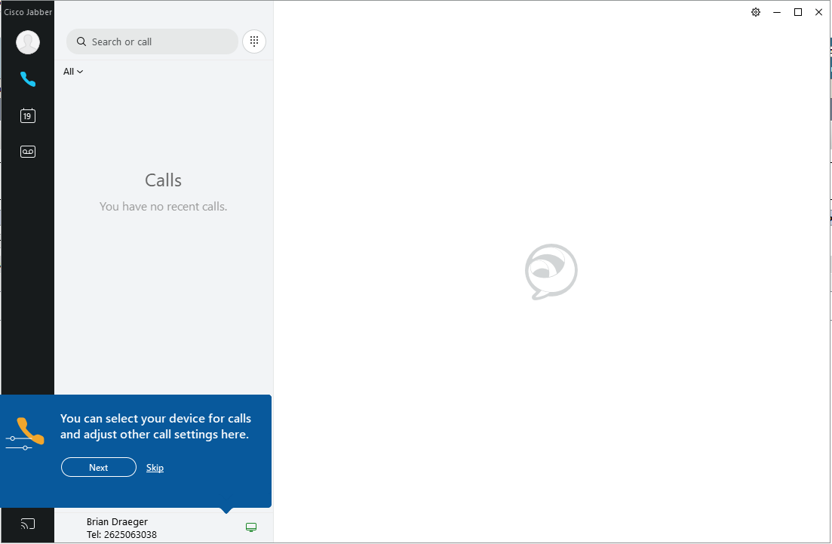

Once you have went thru the onscreen tutorial, please select the gear icon in the upper right hand corner of the screen.
Select Settings, Accounts
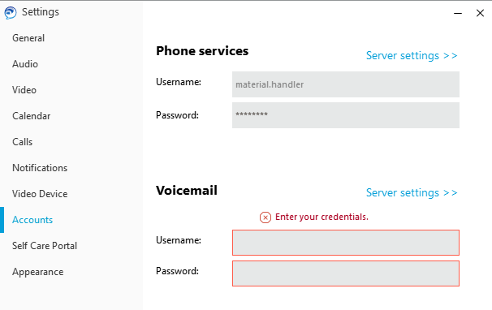
If prompted: Voicemail Username, enter your AD credentials
Click on Apply
Click on OK

