- Either select the tile in HR Central titled ESS for Pay and Time (ADP) or navigate to https://ipay.adp.com
  - Please note, if you haven’t already created an account you will need to register for iPay. The tutorial can be found on the ESG HR Help Center at this link: https://esghrhelpline.zendesk.com/hc/en-us/articles/360052929054-iPay-Registration
- If following from HR Central, make sure to click the iPay link.
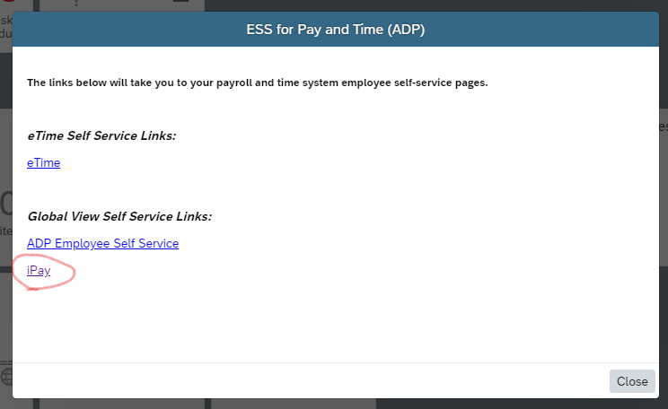
- Once inside of iPay, you will see a menu bar such as the below. You will want to click on the dollar icon.
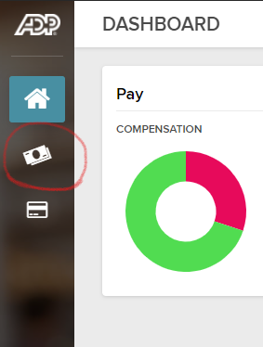
- This will populate your “May Pay” screen. From here, you will click “View Statement”. If you’d like to view any older pay stubs, you will just need to select them and follow the same steps.
