Updating Direct Deposit Through Self Service

Log onto HRC
Click on ESS for Pay and Time Box
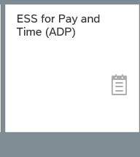

Select ADP Employee Self Service

Select About Me

Select Bank Information
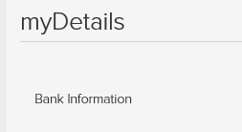
To Add An Additional Account

Select Add to Add A Record
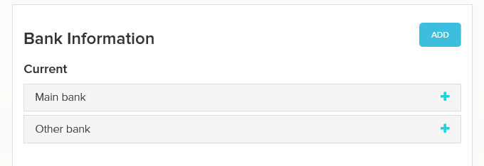
Bank Info will always be Other Bank
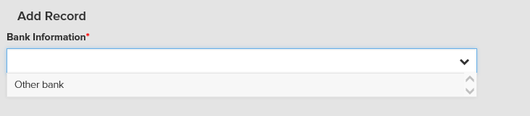

Enter in all Applicable Info:
Routing Number- once this is entered your Bank Name will appear in box to the right

Account Type- once you select checking or savings- box will open for Account Number

Payment Info is always Bank Transfer (ACH PPD)

Enter in standard value if you are wanting a certain dollar amount to go into this account otherwise select the desired percentage.

Save

To Replace An Account Already Set Up

Choose the Plus sign next to Main bank or Other bank and choose Edit
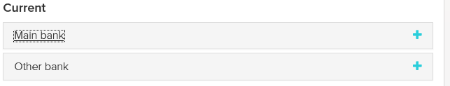

Enter in your new information for:
Routing Number
Bank Account Type
Bank Account Number
Payment Method will be Bank transfer (ACH PPD)
Click on Direct Deposit Authorization Agreement box
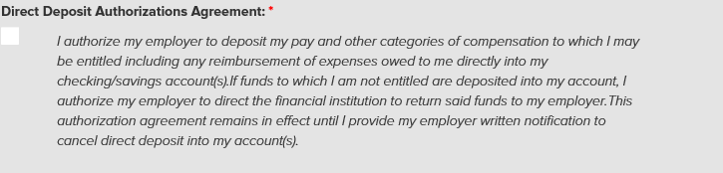

Save

