Open your web browser and type in this address: esghrhelpline.zendesk.com/hc
Press “Go”
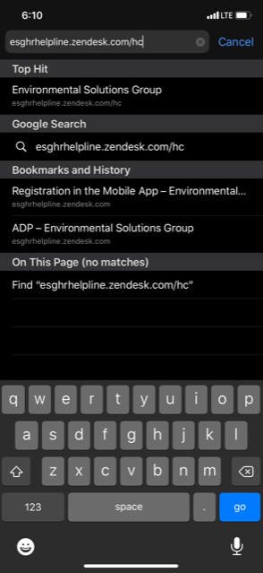

That will bring you to the ESG HR Helpline website.
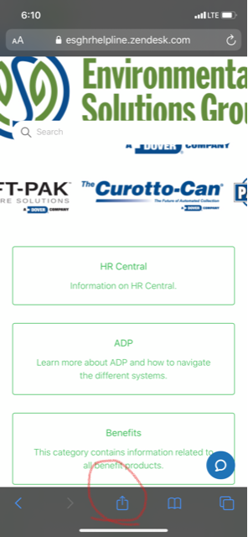

Once there, select the button above, circled in red. That will bring up the below screen.
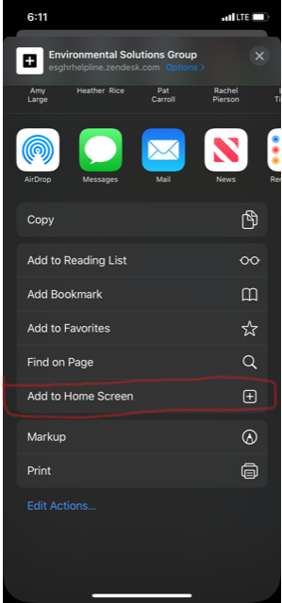
Select “Add to Home Screen”.

