ADP Employee Self-Service GlobalView ESS  Mobile App Registration  Quick Reference Guide | Audience:  All Employees  Objectives:  Understand the registration process for the GlobalView ESS Mobile App.

Name | Details
Name of Transaction | Create a New Hire
Trigger | When a new employee has to be added to HR Central.

HR Central Log in Page:
- Access the HR Central Log in page using the link:
https://hcm2preview.sapsf.eu/login
- The Log In page is displayed. Enter your credentials in the following fields and click the Log in button to log into the system:
  - Company ID
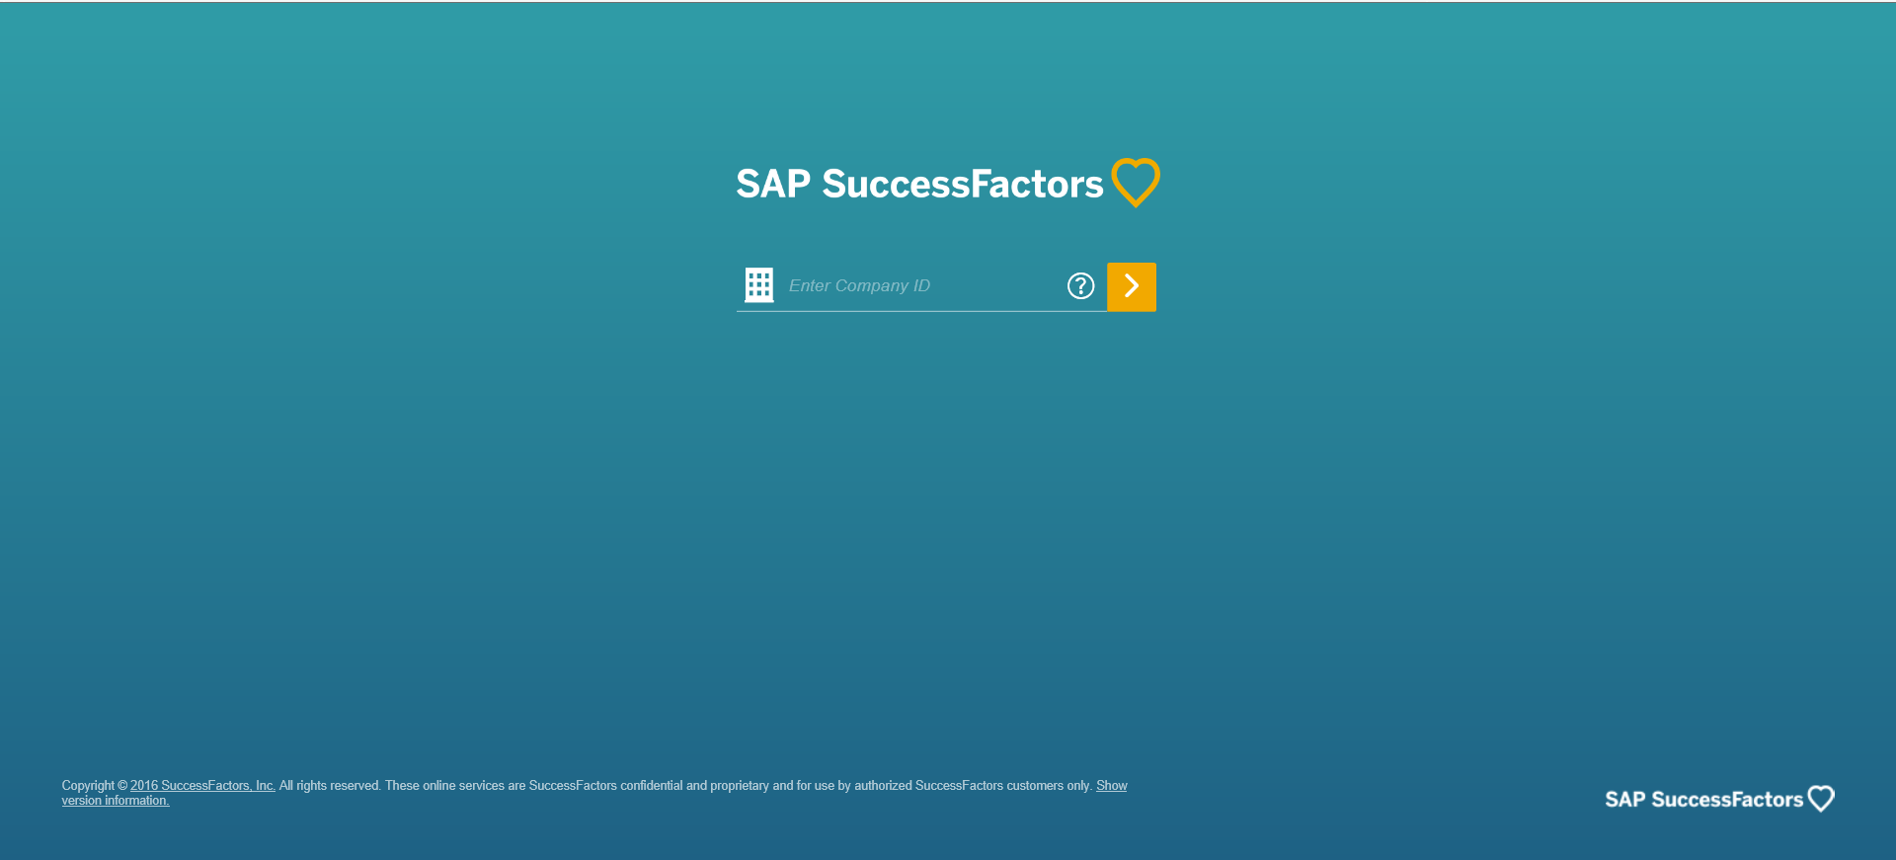
  - Username and Password

Select a Language of your Choice
- Navigate to your name to access the drop down. Click Options.
lick Change Language.

Background: GlobalView ESS allows you to access and print pay stubs, manage banking information (ex. Deposit information), and update your W-4. To use GlobalView ESS on a mobile device, you must follow the preceding steps in addition to registering for Direct Access. Once compelte, you will be able to use GlobalView ESS on your mobile device.

GlobalView ESS Mobile App Registration
Step | Description | Screenshot
1. | Sign into GlobalView ESS using either the HR Central link or the Direct Access link.  - HR Central Link  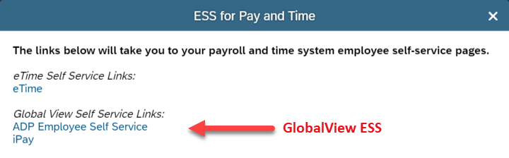  - Direct Access Link  https://portal0013.globalview.adp.com/gvfrmwk3/Dover.home#/login.
2. | From the home page, click on your name and select Settings. | 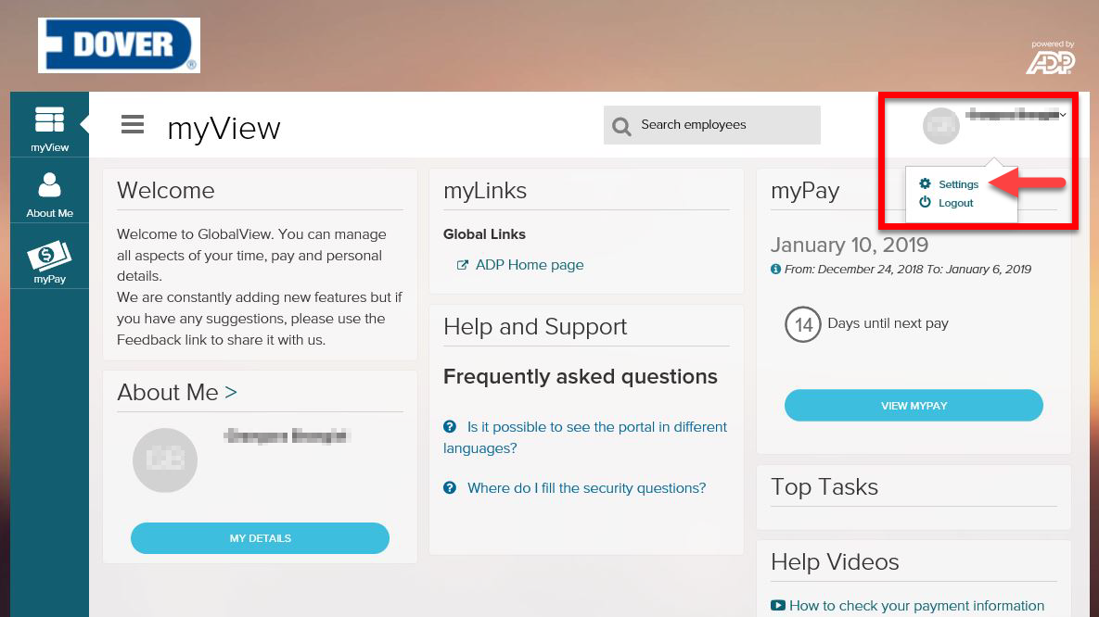
3. | Scroll down to the Go Mobile section. | 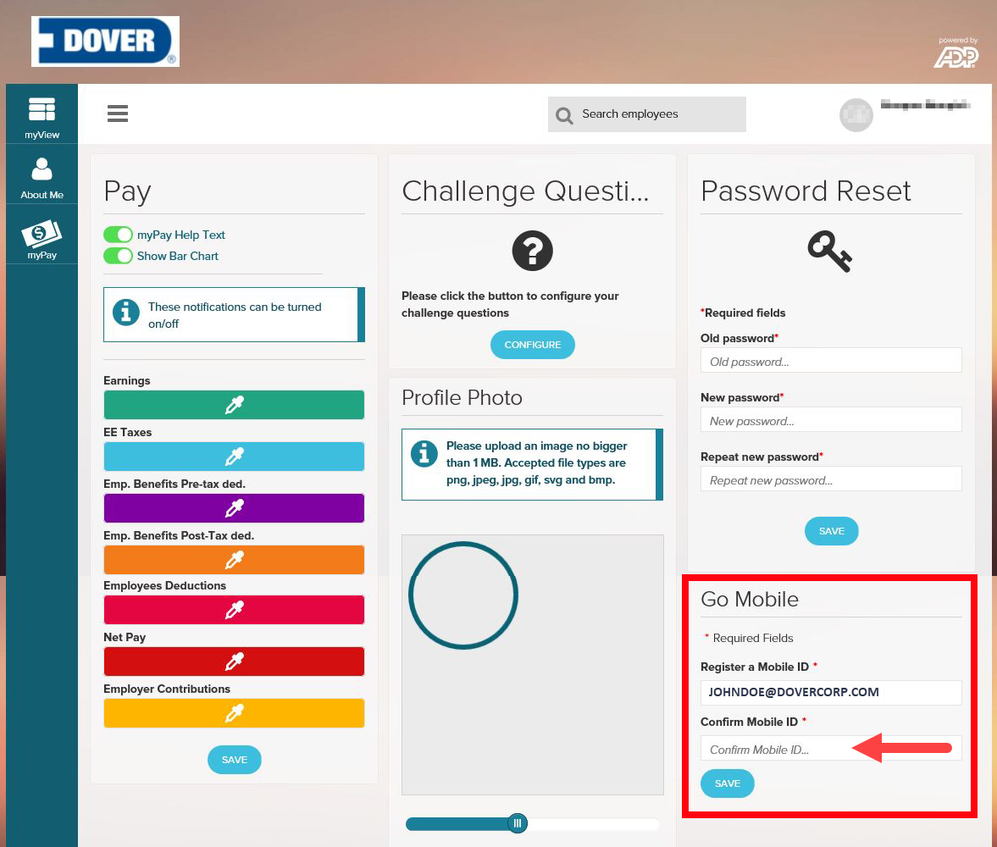
4. | You should see your company email address in the Register a Mobile ID field.  In the Confirm Mobile ID field, copy your company email address.  The mobile ID field is case sensitive.  Note: Non-email users may see a phone number displayed. This is your Mobile ID.
5. | Select Save.
Step | Description | Screenshot
6. | Create a new password. | 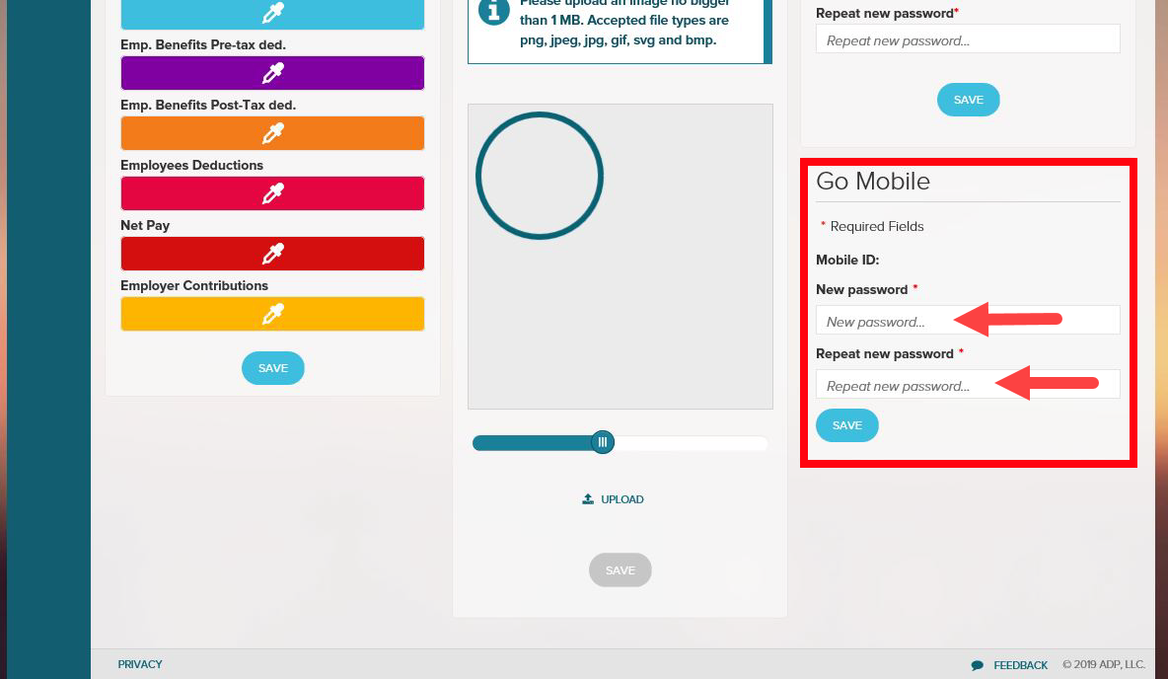
7. | Select Save.
8. | Once the password has been saved, you will see the message in the screenshot to the right.  Make sure you remember your credentials. | 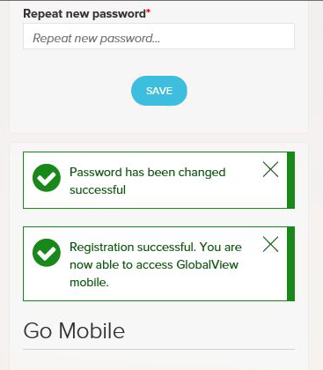
9. | Open the ADP Mobile APP on your phone. | 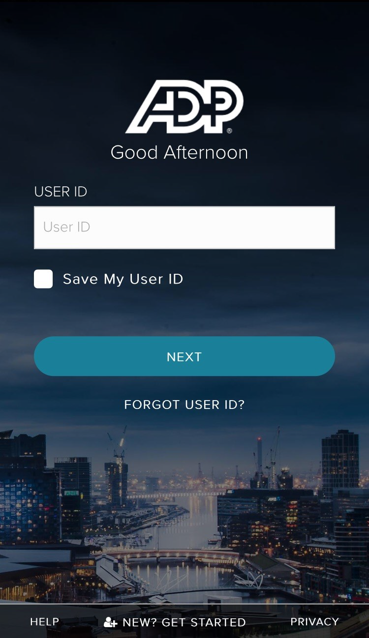
10. | Type in your User ID.  The User ID is the same as the Mobile ID from step 4.

Step | Description | Screenshot
11. | Enter your password.  The password is the same as the password you set up in Step 6. | 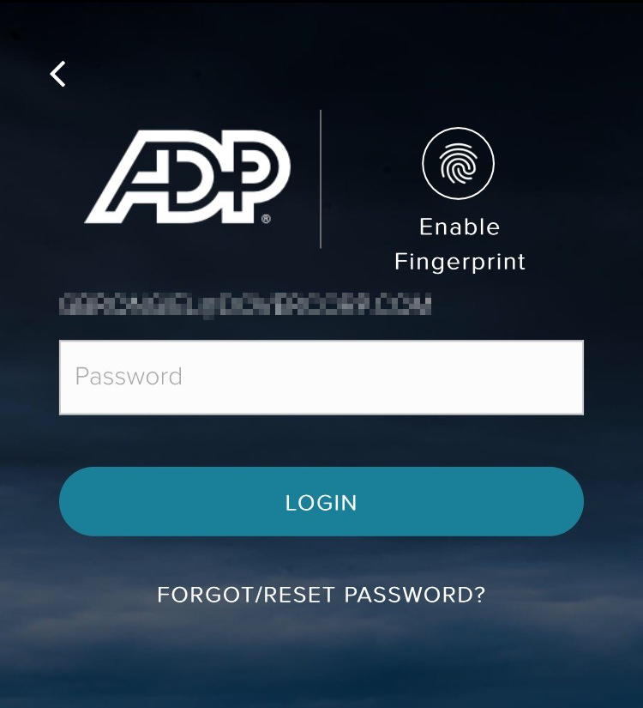
12. | You should now be on the GlobalView ESS version of the ADP Mobile App.  Note: On the landing page, you can view your most recent pay information by selecting the Reveal icon. | 