As you may be aware we are focused on reducing company turnover. In the spirit of those efforts we are conducting 30 / 60 / 90 day reviews for both Supervisors and Team Members. For Supervisors, this is an opportunity to provide feedback about a team member. For team members it will be an opportunity to provide feedback about the company, supervisor, and work atmosphere. Again, this is a new process being launched, to help us in these efforts we ask that you complete the reviews as close to the due date as possible. Additionally, please urge your team members to complete them as they are received as well.
ADP Employee Self-Service GlobalView ESS Registration  Quick Reference Guide | Audience:  All Employees  Objectives:  Understand the registration process for the ADP GlobalView Employee Self-Service web portal.

Below you will find those that are due and a link to the survey, please complete one per team member. If for any reason this person no longer reports to you, simply reply to this email with the reporting change description and we will make this correction. Thank you for your assistance and support in retention efforts.

Review –
60 Day Supervisor Team Member Evaluation- https://www.surveymonkey.com/r/MarathonSup60

Name | Details
Name of Transaction | Create a New Hire
Trigger | When a new employee has to be added to HR Central.

HR Central Log in Page:
- Access the HR Central Log in page using the link:
https://hcm2preview.sapsf.eu/login
- The Log In page is displayed. Enter your credentials in the following fields and click the Log in button to log into the system:
  - Company ID
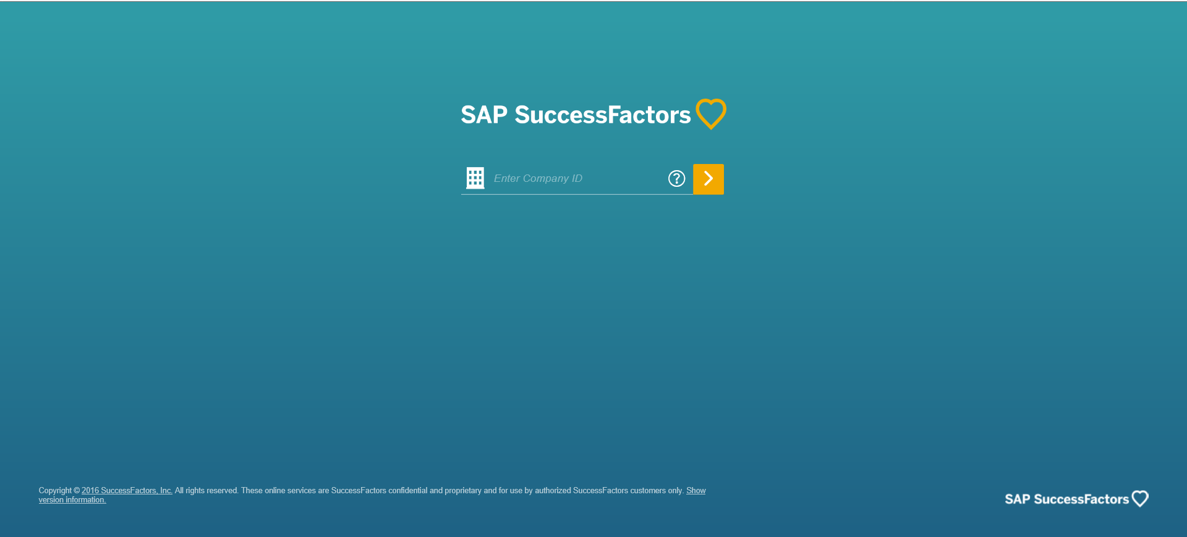
  - Username and Password

Select a Language of your Choice
- Navigate to your name to access the drop down. Click Options.
lick Change Language.

GlobalView Self-Service Registration
Background: GlobalView ESS allows employees to access and print pay stubs, manage banking information (ex. direct deposit), and update W-4 tax withholding information.

Step | Description | Screenshot
1. | Go to https://portal0013.globalview.adp.com/gvfrmwk3/Dover.home#/login
You will receive a user ID and password in your email or from OpCo HR log into GlobalView ESS using the portal above.
2. | Log into GlobalView Self-Service using your assigned User ID and password.  Note: Your User ID for ADP GlobalView will always be your 8 digit HR Central ID (ex. 11001319).  Employees with a valid company email  You will receive two auto-generated emails you’re your username & password credentials from ADP on June 24, 2019.  Employees without a valid company email  HR will distribute user IDs and passwords to all employees without a company email account. | 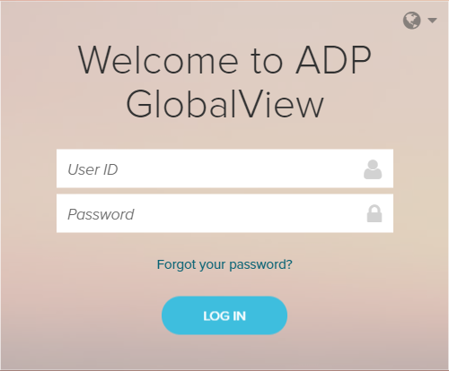
3. | Click Settings under your name at the top right of the screen.
4. | Open the Password Reset portlet and create a new password for future use. | 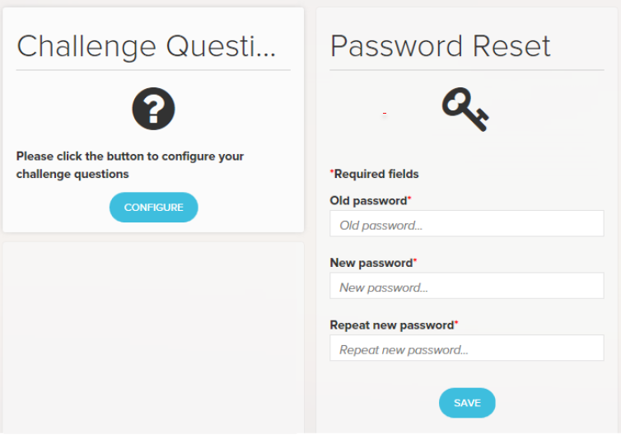
5. | Open the Challenge Questions portlet and complete the challenge questions.
6. | Save credentials for future use.

