ADP Employee Self-Service iPay Registration  Quick Reference Guide | Audience:  All Employees  Objectives:  Understand the registration process for the iPay Employee Self-Service web portals.

Name | Details
Name of Transaction | Create a New Hire
Trigger | When a new employee has to be added to HR Central.

HR Central Log in Page:
- Access the HR Central Log in page using the link:
https://hcm2preview.sapsf.eu/login
- The Log In page is displayed. Enter your credentials in the following fields and click the Log in button to log into the system:
  - Company ID
  - Username and Password

Select a Language of your Choice
- Navigate to your name to access the drop down. Click Options.
lick Change Language.

iPay Registration
Background: iPay allows employees to view and print pay stubs. You can also access your W-2 tax statements. In some cases, historical pay information may be visibile in the iPay web portal.
Step | Description | Screenshot
1. | Go to https://ipay.adp.com. | 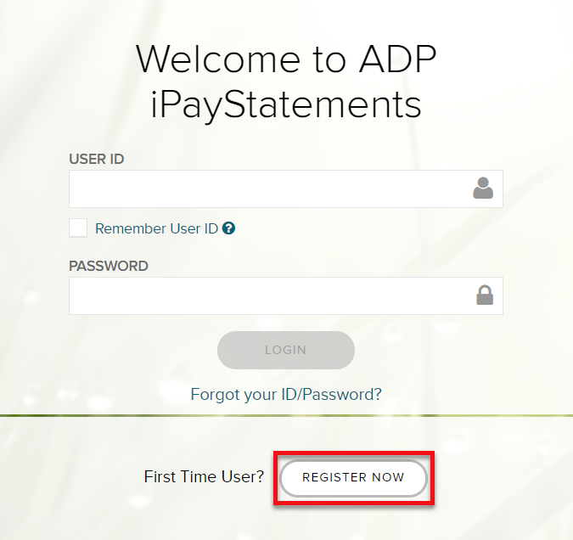
2. | Click Register Now.
3. | Enter the Dover Registration code: doverint-online. | 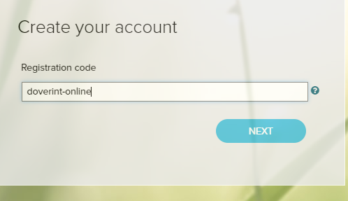
4. | Click Next.
5. | Select Enter Information. | 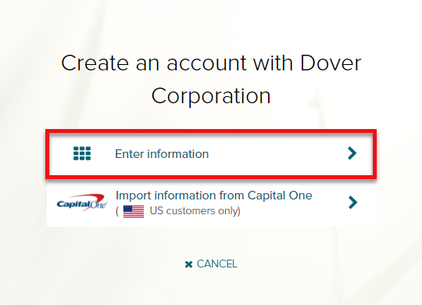
Step | Description | Screenshot
6. | Enter your First Name, Last Name, SSN (without Hyphens) and DOB. | 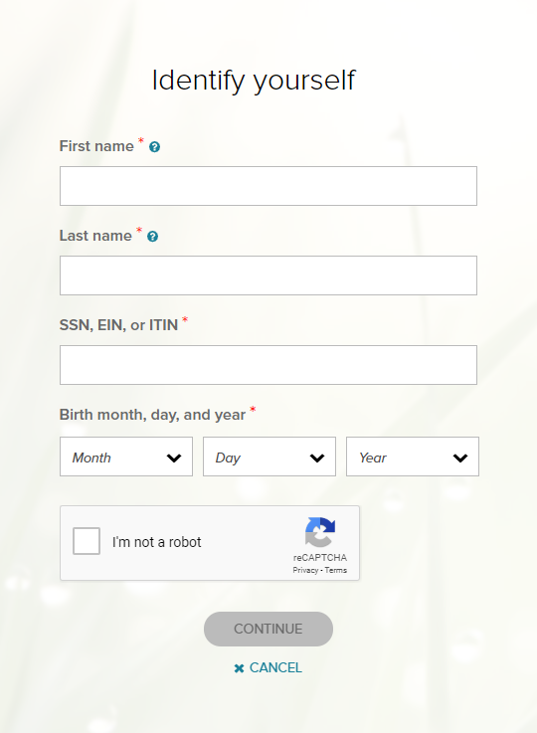
7. | Select I’m not a robot.
8. | Click Continue.  Note: If a prompt indicates your record was not found, contact your local HR administrator.
9. | Enter your Contact Information. | 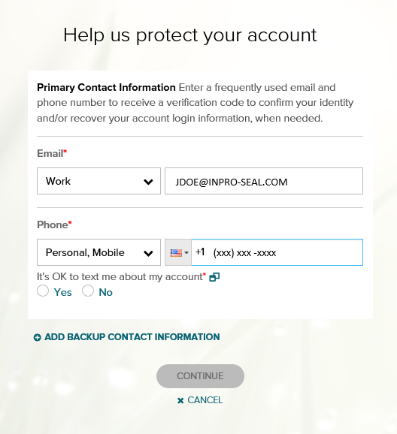

Step | Description | Screenshot
10. | iPay will automatically assign you a User ID.  Create a password.  Save credentials for future use. | 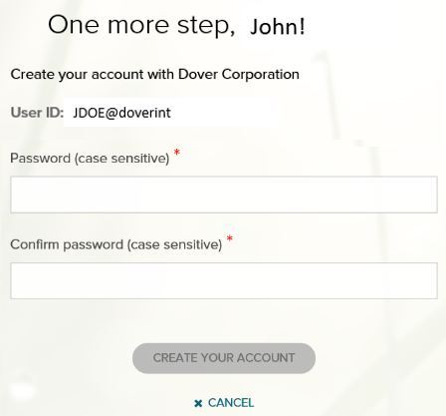
11. | Select Create Your Account.
12. | Registration is complete.  You can sign into iPay using the link below:  https://ipay.adp.com | 