ADP Employee Self-Service eTime Web Portal Registration  Quick Reference Guide | Audience:  All Employees  Objectives:  Understand the registration process for the eTime Employee Self-Service web portal.

Name | Details
Name of Transaction | Create a New Hire
Trigger | When a new employee has to be added to HR Central.

HR Central Log in Page:
- Access the HR Central Log in page using the link:
https://hcm2preview.sapsf.eu/login
- The Log In page is displayed. Enter your credentials in the following fields and click the Log in button to log into the system:
  - Company ID
  - Username and Password

Select a Language of your Choice
- Navigate to your name to access the drop down. Click Options.
lick Change Language.

eTime Web Portal Registration
Background: eTime is a timekeeping service that allows employees to perform timekeeping actions.This includes clocking in and out, approving timecards, and requesting time off. Using Direct Access, employees will be able to access the eTime web portal on any personal device.

Step | Description | Screenshot
1. | Go to https://netsecure.adp.com/public/login/index.fcc.
2. | Click SIGN UP. | 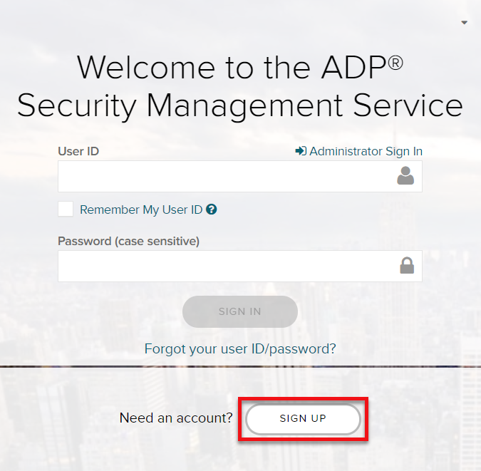
3. | Enter registration code:  DoverCorp1-aiu | 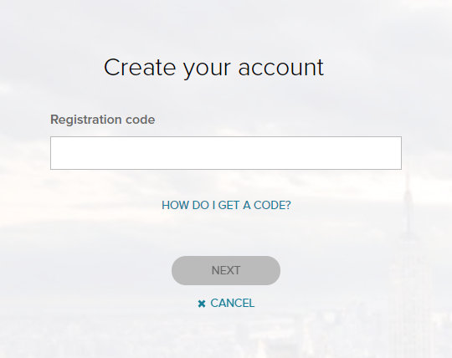
4. | Click NEXT.
5. | Select Enter Information. | 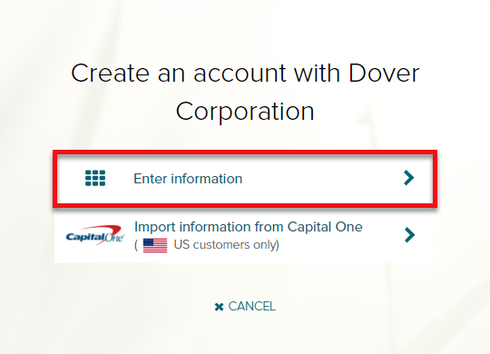

Step | Description | Screenshot
6. | Enter your First Name, Last Name, Date of Birth, and either your Employee ID or SSN.  Note: If you decide to use the employee ID, enter your HR Central ID. | 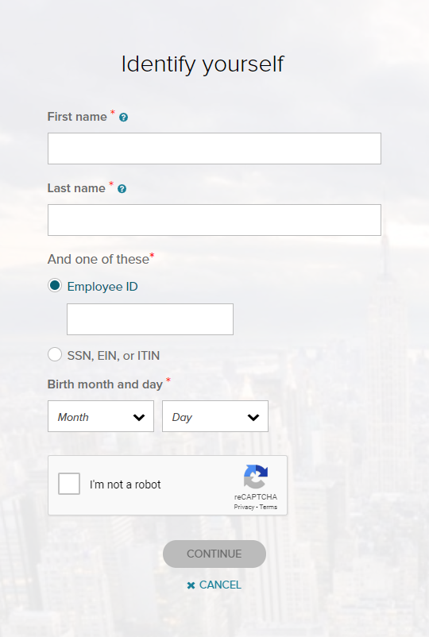
7. | Select I’m not a robot.
8. | Click CONTINUE.
9. | Enter contact information as requested. | 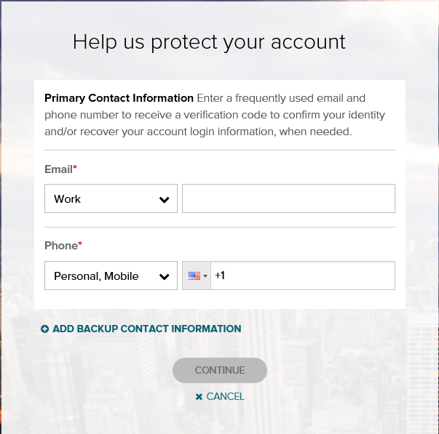

Step | Description | Screenshot
10. | Create a password.  Note: The system will automatically assign you a User ID (for example, JDoe@DoverCorp1.com). | 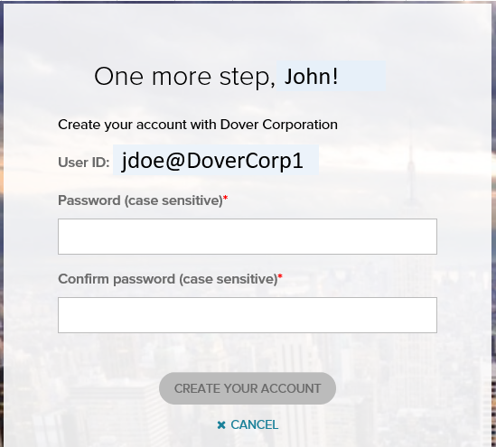
11. | Select and provide answers for the security questions as requested. | 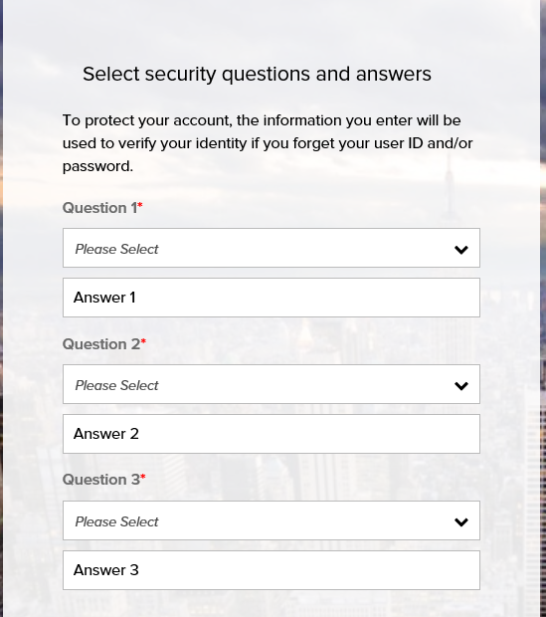
12. | Save credentials for future use.  You can select the MYADP button to go directly to eTime. | 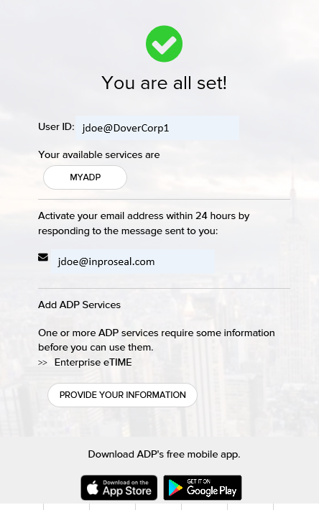
13 | You will use the link below when attempting to Direct Access the eTime web portal:  https://eetd2.adp.com/

