Date: 11/9/2020
To: All ESG Team Members
From: Dover Payroll
RE: Submitting Tax Changes

Effective January 1, 2021, Dover will not accept any paper forms for W4 changes. If you wish to make a change to your Federal Tax Withholdings, you must complete the change online at the ESS portal. Be advised that when making a change, it will normally take up to two pay periods for the change to go in effect. Instructions for the ESS portal are below.

An additional note, IRS regulations state that taxpayers cannot claim an Exempt status to avoid paying taxes on regular or bonus wages. This violates IRS policy and if the IRS audits tax records, a fine of $500 can be levied upon the taxpayer.

How to Change Federal Tax Withholdings

- Log on to HRC
- Click on the ESS for Pay and Time Icon
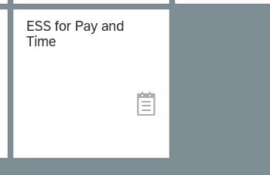

- Select the ADP Employee Self Service Link
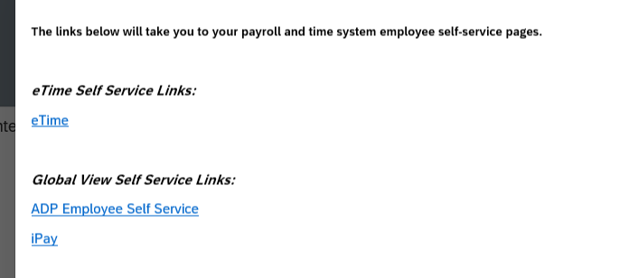

Click on the About Me Icon
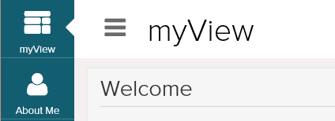

- Click on Withholding Information
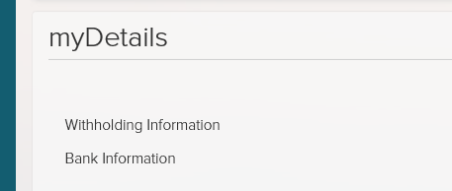

- Click on the Plus sign to change your withholding then Edit
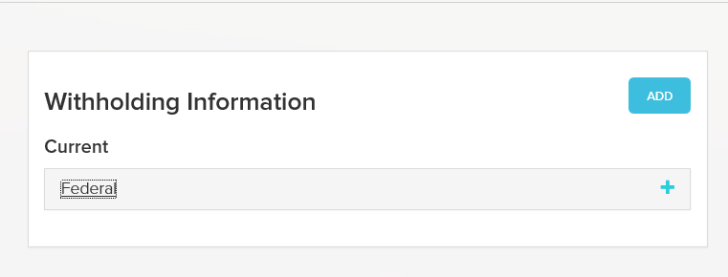

Make you desired changes. Note that ESG cannot advise on what you should claim. If you have questions, please reach out to your tax preparer. Note the Valid From Date as this will determine which pay period the change will be in effect. Click the Declaration Box and Hit Save

